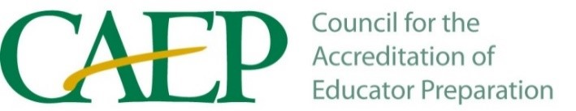

In response to the letter from Dr. Prather, CAEP would like to note that both the accreditation council (over 60 trained volunteers who examine evidence from hundreds of providers) and the appeals committee have reached their conclusions based on a lack of evidence for each of five standards. As such, CAEP disagrees with the assertion that revocation was based on, “procedures not being followed.”

The Accreditation Handbook made available for use throughout the process provides extensive guidance on meeting the evidentiary thresholds for each component of the standards. Exercising appropriate professional judgment, trained reviewers examined the EPPs evidence at multiple discrete points in the process and provided feedback regarding deficiencies. Multiple opportunities throughout the process afforded Franklin with an opportunity to respond to deficiencies. All reviewers concluded that the EPP did not demonstrate adequate evidence of compliance with the standards.

